**AWS Route 53**

* Route 53 provides facility to register domain names and also is DNS as a Service offered by AWS
* To configure Route 53 we need to create a hosted zone and optionally we can also register domain
* Once the Hosted zone is created, ensure the name server records are added to the site where the domain is registered
* Now add a DNS record to point the domain name to load balancer 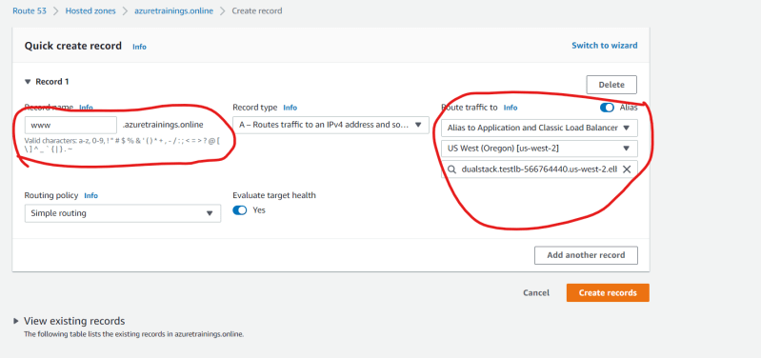
* Follow the classroom video on how to map the settings in DNS Hosted Zone.